St. Stephen's Community United Church of Christ
“We are the Church in the Capital City where prayer is changing people and people are changing things.”

Building Strong and Committed Disciples

May 23, 2022

Dear Golfer:

The Board of Trustees of St. Stephen’s Community Church, United Church of Christ, cordially invites you to join us at College Fields Golf Club in Okemos to participate in the “2022 Rev. Dr. Michael C. Murphy Golf Outing,” to be held on Saturday, July 9th, 2022 to raise funds to provide scholarships for post-secondary education for the youth of our Church and community.

From its founding, this outing was always important to our late Pastor Murphy, and he continued to support it after leaving St. Stephen’s. Registration is at 8:00 am with a shotgun start of 9:00 am, and features 18 holes of golf, a golf cart, trophies, prizes, and a box lunch.

As a special offer, those foursomes who register by June 17th will pay only $220.00! So, while our regular cost will be $65.00 per person, or $260.00 for each foursome, the early registering foursomes will receive the special discounted offer.

Enclosed is a registration form. To avoid a late registration fee, please return your completed form, along with a check payable to St. Stephen’s Community Church no later than July 1, 2022, to St. Stephen’s Community Church, 1007 Kimberly, Lansing, MI 48912. Attention: Ralph Sims.

We are also seeking sponsors and prize donations. If you are interested in participating as a sponsor or for sponsorship information, please call Kathy Thomas 517-898-7738 or Ralph Sims at 517-862-2822.

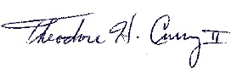
Please come out and join us for a day of fun for a worthy cause – our youth! We thank all our past participants and hope to see you again this year. If you have not participated before, you are in for a treat! Thank you all in advance for your support and please keep our Church and our youth in your prayers.

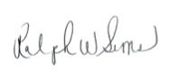
Sincerely,
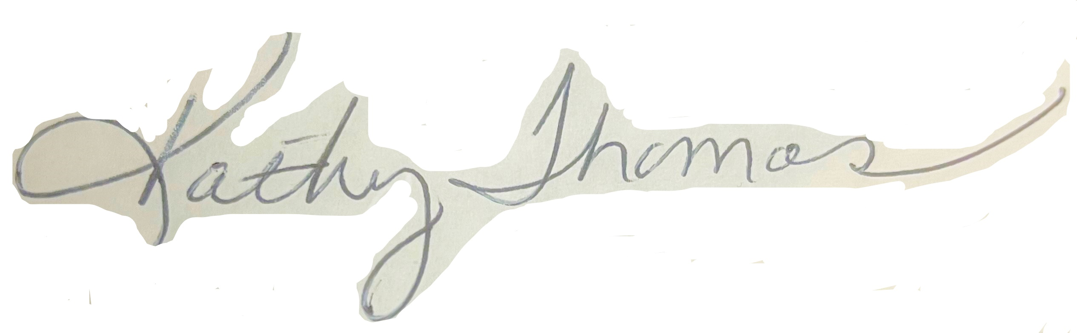

Rev. Sameerah L. Shareef, M.Div. Kathy Thomas Ralph Sims
Senior Pastor Co-Chair, Golf Committee Co-Chair, Golf Committee

Enclosure

Senior Pastor: Rev. Sameerah L. Shareef, M.Div.
1007 Kimberly Drive • Lansing • Michigan 48912 Telephone: (517) 484-2180

